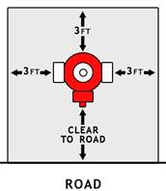               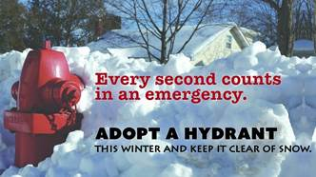

Snowfall, combined with the snow plowed from roadways, often bury fire hydrants under a large amount of snow, thus making them difficult to find and use. Should there be a fire nearby, precious time is lost as firefighters work to locate hydrants and shovel snow away before hoses can be hooked up to them. In the situation of a fire, time is critical and every second counts. The extra minutes that a firefighter spends digging out a hydrant can make a big difference in how quickly a fire can be extinguished and the damage to be limited.

Don't let your neighborhood hydrant remain undercover -“**Adopt a Fire Hydrant**”.

We are asking that you help us by keeping the fire hydrant closest to your residence or business clear of snow. Snow should be removed about three-feet (3') away from the hydrant in all directions and a pathway cleared between the hydrant and the nearest roadway.